**CAMEROON GENERAL CERTIFICATE OF EDUCATION BOARD**

Technical and Vocational Education Examination

**DIGITAL MARTKETING PRACTICE 3**

**7070**

**JUNE XXXX ADVANCED LEVEL**

|  |  |
| --- | --- |
| Specialty Name (Specialty Code) | **MARKETING**  **(ACC)** |
| Subject Title | **DIGITAL MARTKETING PRACTICE** |
| Paper No. | **3** |
| Subject Code No. | **7070** |

**One hours**

**INSTRUCTIONS TO CANDIDATES**

***.***

***You are reminded of the necessity for good English and orderly presentation in your answers.***

***You are advised to read carefully through the question paper, before you begin your answers.***

_______________________________________________________________________________________ ***Turn Over***

XXXX/7070/3/C

***© 2019 CGCEB***

**SECTION A: COMPULSORY QUESTION**

_________________________________________________________________________________________________

1. MAYOR Vegetable oil can be purchased according to the prices presented in appendix 1.

The price of vegetable oil has been constant but the data layout has changed so as to know the costs for each of the quantities. Appendix 2 is a table enabling to calculate the cost of 1600 litres.

(a) Start excel

(b) Type the table in appendix 1 respecting all the formatting

(c) Introduce in cell D5, the formula =IF(B5<=500,B5*$D$2,IF(B5<=1000,(500*$D$2)+(B5-

500)*$D$3,(500*$D$2)+(500*$D$3)+(B5-1000)*$D$4)) enabling to calculate the cost of 10 litres of oil

Then obtain the cost of 1600 litres, 483litres, and 2001litres and 500 litres automatically.

(d) Introduce in cell E6, the formula =IF(D5>=1000000,"Within budget","Over budget"), enabling to

determine if the cost is within the budget or not.

(e) Introduce in cell D10, the appropriate formula enabling to obtain the total amount.

(f) Retype the table in appendix respecting all the formatting

(g) Introduce in cell E14, the formula =MIN(E$12,$B$14), in cell E15, the Max function =MAX(IF(E12<$B$14+$B$15,E$12-$B$14,$B$15),0) and in cell E16 the if function =IF(E$12>1000,E$12-1000,0) enabling to calculate the number of litres at the cost of 2300frs, 2000frs and 1500frs respectively.

(h) Introduce in cell E17, the appropriate SUMPRODUCT enabling to calculate the cost of 1600 litres of oil.

(i) Safe your work using your candidate number, print and exit excel.

**APPENDIX 1: PRICE SCHEDULE FOR VEGETABLE OIL**

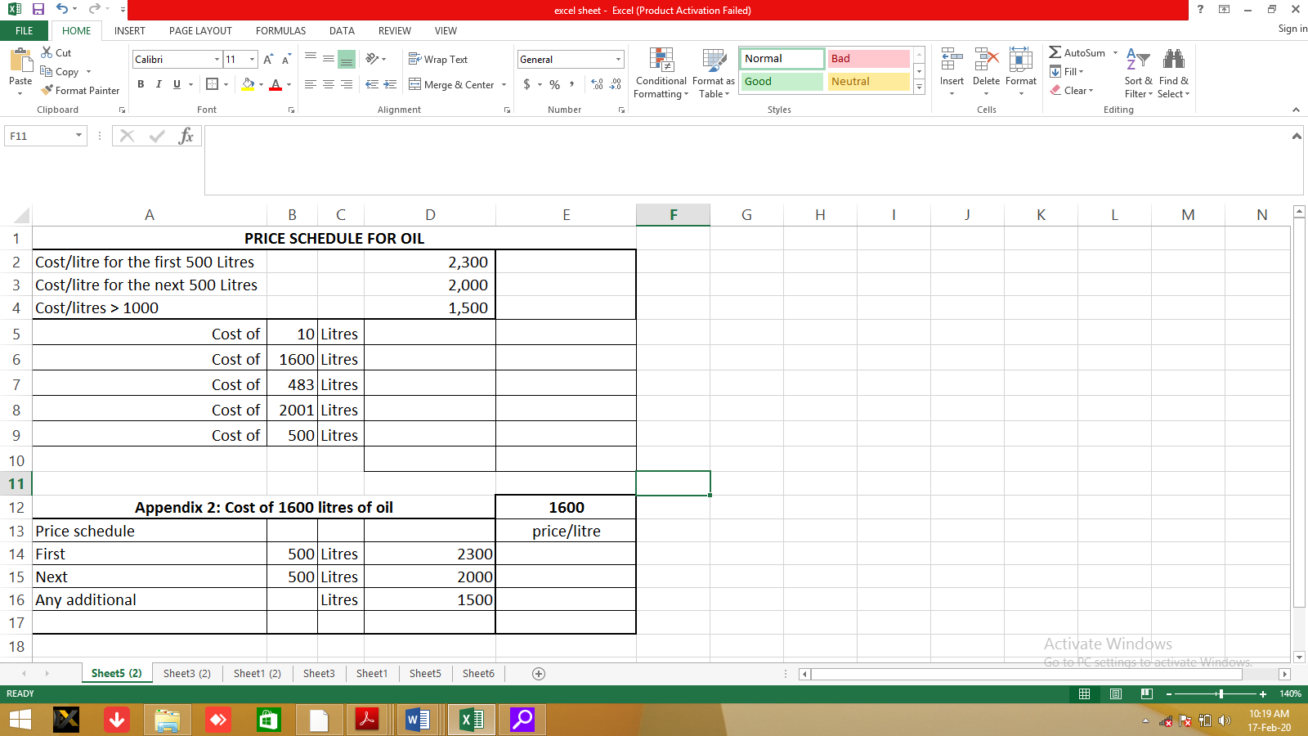

_________________________________________________________________________________________________

**SECTION B: ANSWER ANY TWO QUESTION**

_________________________________________________________________________________________________

1. The website of Peter and sons to attract traffic. But he is aware that Things like the age of the domain,

the reputation of the author, number and type of references (incoming links), social media strategy and content freshness play an important role.

#### **(a) What are the most effective ways for Mr Peter to increase traffic to his website?**

#### **(b) What are the key areas where you can use keywords to optimize your site ranking?**

_________________________________________________________________________________________________

2. To take your marketing strategy to the next level, every marketer should have some useful digital marketing tool .

#### **(a) Name 5 useful Digital Marketing tools**

#### **(b) Explain PPC or Pay Per Click advertising?**

_________________________________________________________________________________________________

3. Cobiro is an easy-to-use, intelligent advertising platform that fully automates Google Ads. Join more than 50,000 customers who currently manage ads better.

#### **(a) Explain Google Adwords.**

#### **(b) Explain Google AdWords Remarketing.**